2.2 Legislation and regulations
The government sector is built on a system of legislation and regulations.
Legislation is passed by Parliament and sets out broad legal and policy principles about a topic. It describes requirements and can include punishments for breaking the law.
Regulations, rules, by-laws and some codes (subsidiary legislation) define and control how an authority operates to implement the law. They have legal effect.
Some laws give an authority and its officers powers and functions (enabling legislation). Other laws set out how an authority governs its operations and how officers are to conduct themselves. Laws may also provide for an authority to take action against officers who do not comply with the expectations it sets.
Accountability mapping can help an authority reflect obligations arising from legislation and regulations in its internal controls, policies and procedures.

Why are legislation and regulations important?
Legislation and regulations set the foundation for what authorities, and those who work in them, can and cannot do. Authorities operationalise these obligations and requirements through expectations, standards (like codes of conduct), policies and procedures. Together, they create a consistent understanding of what is required and set the parameters for officers’ actions and decisions.

Ideas for good practice for legislation and regulations

Good practice
- Map accountabilities to clarify the legislative and external policy requirements that apply to the authority. Characteristics of an accountability map are shown in the diagram below. It includes documenting:
  - legislation that provides the authority’s powers and functions
  - legislation, regulations and external policy requirements that apply to and govern the authority’s operations
  - internal (audit committee) and external (Office of the Auditor General, Public Sector Commission) stakeholders who provide oversight
  - what these instruments or stakeholders require the authority to do or report on, and when.
- Consider developing a calendar with requirements of external oversight bodies.
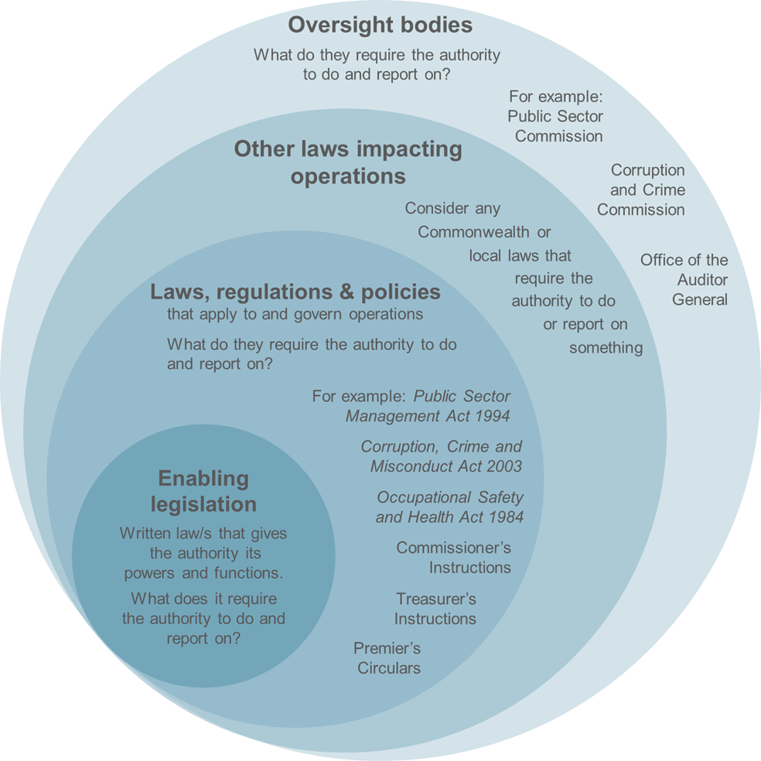

The Legislative Process
- Home
- The Legislative Process

One of the functions of Parliament is to make laws. To make a law, Parliament enacts legislation which is also known as statutes or Acts of Parliament.
An Act of Parliament starts as a Bill in one of the Houses. A Bill is the draft of a proposed law. Most Bills deal with management of public affairs and the implementation of Government policy and are introduced by a Minister, but a member of either House is entitled to introduce a Private Member's Bill.
To become an Act, a Bill must pass through a number of formal stages. These are -

The Introduction and First Reading
A Minister or member of either House may introduce a Bill. This is usually agreed to without debate. Immediately after introduction, the Bill is "read" a first time; that is, the Clerk reads the title of the Bill.

The Second Reading
The member/Minister in charge of the Bill starts the second reading debate with a speech that explains the intended effect of the proposed legislation. All members are entitled to make one speech during that debate with the member/Minister in charge of the Bill having a right of reply in which the various arguments raised in debate are answered.
The Second Reading is the most important stage through which a Bill passes because the whole principle or policy of the Bill is at issue. At the end of the Second Reading the main vote on the Bill is taken.

Committee of the Whole House
When a Bill has passed the Second Reading, the House forms itself into a 'Committee', presided over by the Chairman of Committees.
The Bill is then dealt with clause by clause to ensure that when it becomes an Act, it will carry out Parliament's intention. At this stage, amendments can be moved to the clauses of the Bill. In some cases a Bill may be committed to the Committee of the Whole House more than once, mostly to tidy up amended clauses.

Referral to Other Committees
In the Legislative Council, Bills may be referred to an appropriate standing committee for its consideration and report to the Committee of the Whole House. This is a good example of how the Legislative Council performs its review function. Similarly, in the Legislative Assembly, Bills may be referred to a select committee or a legislation committee.
It is possible to bypass the Committee of the Whole House stage when a Bill is not controversial. In other words, if all Members of a House agree with the Bill, it need not be referred to the Committee of the Whole House and may proceed directly to the Third Reading.

The Third Reading
Once the House has dealt with the Bill in the Committee of the Whole House, the next stage is the Third Reading. Although this stage is mainly formal, the Bill is occasionally debated again when its subject matter is controversial.

Presentation to the Other House
The Bill is then sent to the other House where, following receipt by Message (a formal means of communication between the Houses) rather than introduction, the same procedure takes place.

Assent by the Governor
Having passed through both Houses, the Bill is presented to the Governor, who assents to it in the name and on behalf of the Monarch. On assent, the Bill becomes an Act of Parliament.

Proclamation
Some Acts of Parliament specify that they, or portions of them, do not come into operation until they are proclaimed by order of the Governor (on the advice of the Executive Council). A notice of proclamation must be published in the Western Australian Government Gazette.

Disagreements between the Houses
If the two Houses cannot agree on amendments made to a Bill, each may appoint a number of members to meet and try to settle the difference. This procedure is known as a Conference of Managers. If the Conference of Managers fails to reach agreement, the Bill fails.

Financial (Money) Bills
Under section 46 of the Constitution Acts Amendment Act 1899, all Bills that involve expenditure of public moneys must originate in the Legislative Assembly. This is to ensure that management of public expenditure remains in the hands of the Government (which is formed from the party or coalition of parties having a majority in the Legislative Assembly). Although money Bills must originate in the Legislative Assembly, the Legislative Council can veto the Bills and may amend certain types of money Bills. The interpretation of section 46 has been the source of many disputes between the two Houses.

Making a law in the Australian Parliament
This fact sheet explains the law-making process in the Australian Parliament. It also describes where ideas for laws come from and the history of law-making in the Parliament.
- 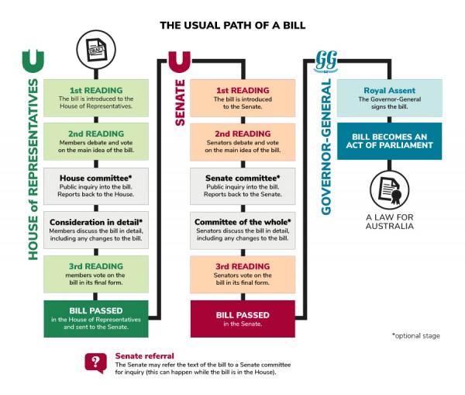

The usual path of a bill.
PARLIAMENTARY EDUCATION OFFICE (PEO.GOV.AU)
Slide 1 details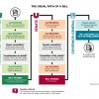
Slide 2 details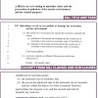
Slide 3 details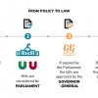
Video
Laws are formal rules which society uses to define how people and organisations are expected to behave. Section 51 of the Australian Constitution gives the Australian Parliament the power to make laws in relation to certain matters. In Parliament, a bill is a proposal for a new law or a change to an existing one. Bills often seek to address an important issue facing the Australian community.

Path of a bill
A bill can only become a law if it is passed by a majority vote in the Senate and the House of Representatives. The bill must be agreed to in identical form by both the Senate and House, and given Royal Assent by the Governor-General. It is then known as an Act of Parliament. An Act specifies the date on which the new law will commence. Often this is the day after it receives Royal Assent.
Most bills are introduced into the House of Representatives and then sent to the Senate. Bills may start in the Senate, except for money and taxation bills. Most bills are introduced by government ministers; however, other members of parliament can introduce their own bills, known as private members' or private senators' bills.
It may take months or even years for a bill to pass through Parliament. However, an urgent bill can be passed in a matter of hours or days. Well over 100 bills are introduced into Parliament each year and about 90 per cent of government bills are passed into law.

Origins of bills
Bills can start in different ways:
- A government department may advise its minister about a specific problem that exists. The minister may then arrange for a bill to be drafted to fix the problem.
- Community groups, businesses or lobby groups may be interested in changing or improving a specific area of Australian law. They can approach members of parliament with suggestions for bills.
- Political parties have their own ideas about how Australia should be governed. In Parliament, parties introduce bills which aim to put their ideas into action.
- The Parliament can set up a parliamentary committee to examine a current issue. If the issue requires action, the committee may suggest that a bill be introduced.

History
The law-making process used in the Australian Parliament comes from the practices of the British Parliament, developed over many centuries. The word ‘bill’ probably comes from the Latin word bulla, meaning ‘seal’. In medieval times, seals were put on documents written by a king or person in authority. During the 16th century in England, the word ‘bill’ came to mean a draft for an Act of Parliament.
The practice of the Clerk reading the bill aloud 3 times dates back to the early British Parliament, before printing was invented and many people could read. The Clerk had to read the bill aloud so that members of parliament knew what the bill was about. Today bills still go through 3 ‘readings’ but the Clerk only reads the title of the bill.

